PROJECT PLANNING PHASE
Date | 31 January 2025
Team ID | LTVIP2026TMIDS73798
Project Name | Online Payments Fraud Detection Using Machine Learning

4.1 Planning Logic
The planning logic defines how the fraud detection system was systematically developed from raw data to deployment.
The development process followed a structured Machine Learning lifecycle.

4.1.1 Data Collection
The first step in planning was acquiring a relevant dataset containing online transaction records.
Dataset Characteristics
The dataset includes:
- Step (time step of transaction)
- Transaction Type
- Amount
- Old Balance Origin
- New Balance Origin
- Old Balance Destination
- New Balance Destination
- Fraud Label (Target Variable)
Data Source
The dataset consists of structured transaction records suitable for supervised classification.
Purpose of Data Collection
- To identify patterns of fraudulent behavior
- To train a machine learning classification model
- To evaluate fraud detection accuracy

4.1.2 Data Cleaning
Raw transaction data may contain inconsistencies, missing values, or irrelevant information.
The following cleaning steps were performed:
- Handling Missing Values
- Checked for null values.
- Ensured no incomplete transaction records were used.
- Removing Irrelevant Features
- Columns not contributing to fraud detection were excluded.
- Data Type Conversion
- Ensured numerical features were properly formatted.
- Converted categorical transaction type into numeric format.
- Duplicate Handling
- Checked and removed duplicate transaction entries.
Importance of Data Cleaning
- Improves model accuracy
- Prevents bias
- Reduces noise in training data
- Ensures reliable predictions

4.1.3 Exploratory Data Analysis (EDA)
Exploratory Data Analysis was conducted to understand data distribution and fraud behavior patterns.
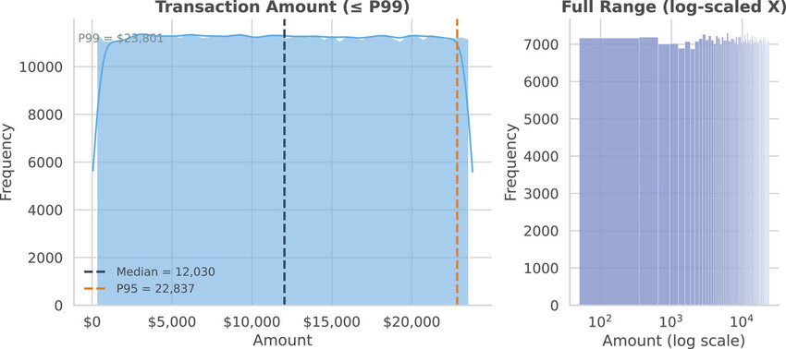

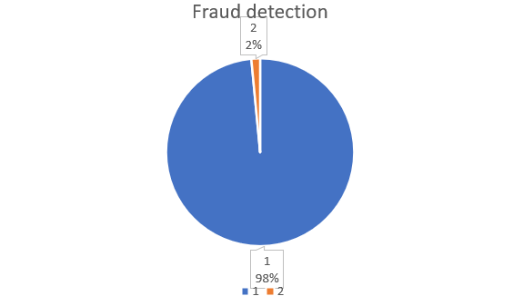
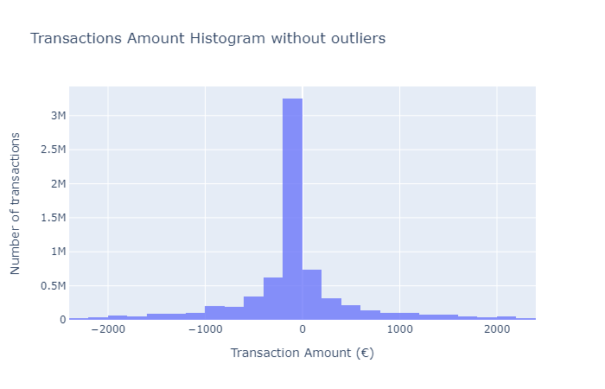
EDA Activities Performed
- Class Distribution Analysis
- Checked number of fraud vs legitimate transactions.
- Observed class imbalance (fraud cases much fewer than legitimate cases).
- Transaction Amount Analysis
- Analyzed large-value transactions.
- Identified abnormal transaction behavior.
- Balance Comparison
- Compared old and new balances.
- Fraud cases often showed abnormal balance mismatches.
- Correlation Analysis
- Identified features strongly influencing fraud.
- Helped in feature selection.
Outcome of EDA
- Fraudulent transactions often involve large amounts.
- Balance inconsistencies are strong fraud indicators.
- Dataset is imbalanced.
- Random Forest suitable for such data.

4.2 Project Planning
Project planning defines how the project was organized and executed efficiently.
4.2.1 Development Strategy
The project followed a structured ML development workflow:
- Problem Understanding
- Data Collection
- Data Preprocessing
- Model Selection
- Model Training
- Model Evaluation
- Model Saving
- Web Application Development
- Testing and Validation
4.2.2 Model Development Plan
Phase 1 – Data Preparation
- Clean dataset
- Encode categorical variables
- Split into training and testing sets
Phase 2 – Model Building
- Implement Random Forest classifier
- Tune hyperparameters
- Train on training data
Phase 3 – Model Evaluation
- Evaluate accuracy
- Analyze confusion matrix
- Compute precision, recall, F1-score
Phase 4 – Deployment Preparation
- Save trained model using Joblib
- Save feature column order
- Prepare input preprocessing logic

4.2.3 Deployment Planning
Deployment involved:
- Creating Streamlit UI
- Loading saved model
- Aligning input features
- Displaying prediction and risk level
The deployment logic ensures:
- Fast prediction
- Correct feature alignment
- User-friendly interaction
4.2.4 Risk Management Plan
Risk | Mitigation Strategy
Class imbalance | Use evaluation metrics beyond accuracy
Overfitting | Use ensemble method (Random Forest)
Incorrect input format | Implement validation checks
Feature mismatch | Save and load feature columns
4.2.5 Time Planning (Execution Timeline)
Stage | Activity
Week 1 | Problem Analysis & Data Study
Week 2 | Data Cleaning & EDA
Week 3 | Model Training & Evaluation
Week 4 | Web Application Development
Week 5 | Testing & Documentation

4.3 Outcome of Project Planning Phase
The planning phase ensured:
- Structured model development
- Reduced implementation errors
- Smooth deployment process
- Accurate fraud prediction

